*Software Development Life Cycle Documentation: Assessment 2: Software Project*

*IT5016D_Assessment 2_20220956*

*By Louie Joh Candelario*

*Overview:*

*This document details the process of going through the (SDLC) software development life cycle while creating the software project for assessment 2. The software project has been analyzed and designed to consider each phase of the SDLC. Although the project was continually added upon since module 2, the project has been reanalyzed and reassessed based on the different steps of the software development life cycle.*

*Phase 1: Planning*

*In this stage, planning for the tackling of the project started. This step is crucial in planning out which syntax and systems I needed to complete the project. I started creating the project in Module 2 incrementally, then revisited the coding process when I reached the software development life cycle module. This helped me greatly organize the thought process of how I should tackle the project moving forward. It allowed to reevaluate what I have done so far and how I can move forward with the project to achieve the desired outcome. I was able to plan out which functions of the software project I should do first and which ones I can create down the line. Having a concrete schedule and plan helped me stay on track and reach my smaller goals.*

*Phase 2: Requirement Analysis*

*In this stage, I was able to identify all of the technical requirements indicated in the assessment. Stage 2 made me clarify what technical and specific requirements I needed to incorporate in my design. Technical requirements such as the input to take from the customers, the ticket format, the ticket statistics format, the 2 classes to be used and the password generator were all taken into account for the design of the software project. This phase gave me an overall picture and end goal of the project. I was able to outline what each function had to do and how the output should look. In line with the plan that I created from phase 1, I was able to align them together and create a cohesive plan that outlined which functions I would work on with specific dates.*

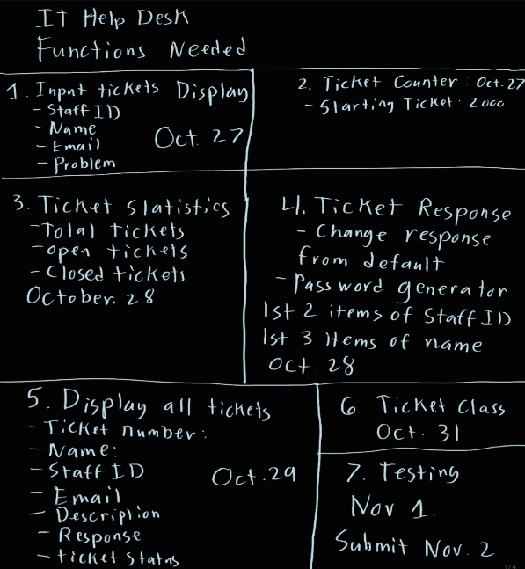

*Phase 3: Solution Design*

*The initial solution that I created for the project was one using only functions that were connected together. I completed more than half of the project using only this approach. When I got to the classes lessons, I realized that using classes with methods inside them were more efficient yet confusing at the start. Once I was able to correctly understand and use classes together, it made the whole process easier and more efficient. I used my initial approach as my base then recreated it using classes.*

*Phase 4: Detailed design*

*This phase helped me refine the technical requirements laid out in the phases 1 and 2. Even though the code will only be displayed on the console, I designed the proper lay outs for specific functions so that it could be readable and user friendly.*

*I was able to lay out the following:*

* *The opening menu and its input choices*
* *The ticket format for displaying a specific ticket and all tickets*
* *The ticket statistics format*
* *Editing the ticket response and password generator*

*Phase 5: Construction*

*This phase was the focal point of the project. Most of my time was spent coding and creating the functions. I was also testing each part of the code as I was going along to ensure that it was working before connecting it to the next function. I consulted with my professor and my cousin to mentor me along as I made mistakes and learned. I was given helpful information in connecting the classes and methods together. The object-oriented programming part of the code was a little complicated than I thought, but once I understood it, I was able to create the functions that I needed in the way they were designed. Once I finished the functionality of the software program, I tested the code to ensure that each part was working correctly. This was in line with the instructions that I made for the use of the program.*

*Phase 6: Testing*

*This phase was in line with the construction phase. I kept repeating tests of the code as I went along in the construction phase. This phase was a critical phase because of not only did it help me find the errors in the code but it also helped me understand the code better. It made me think better, understand why these errors came about and where to look for them.*

*Phase 7: Deployment*

*This phase is the final phase and includes the use of the coding program. The detailed instructions that go with the program are there for the user to test and use the program. In this case, the deployment stage is the submission stage of the assignment when all the required documentation is submitted.*